**User Manual**

on

**Archive Management**

**Project Manager:**

Dr. Kazi Masudul Alam

Associate Professor

Computer Science & Engineering Discipline

Khulna University, Khulna, Bangladesh.

**Developed by:**

Sumaiya Tasnim (170204)

Nakshi Saha (170236)

**Digital University Homepage:**

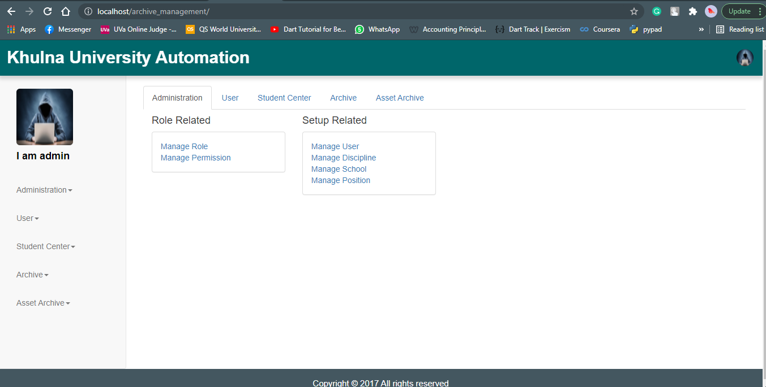

Fig 1: UI of Homepage

The Archive management has five sections, i.e. Project, Thesis, Publication, Email, and Organisation. The path to the Archive section is **Home -> Archive.**

**Archive Section:**

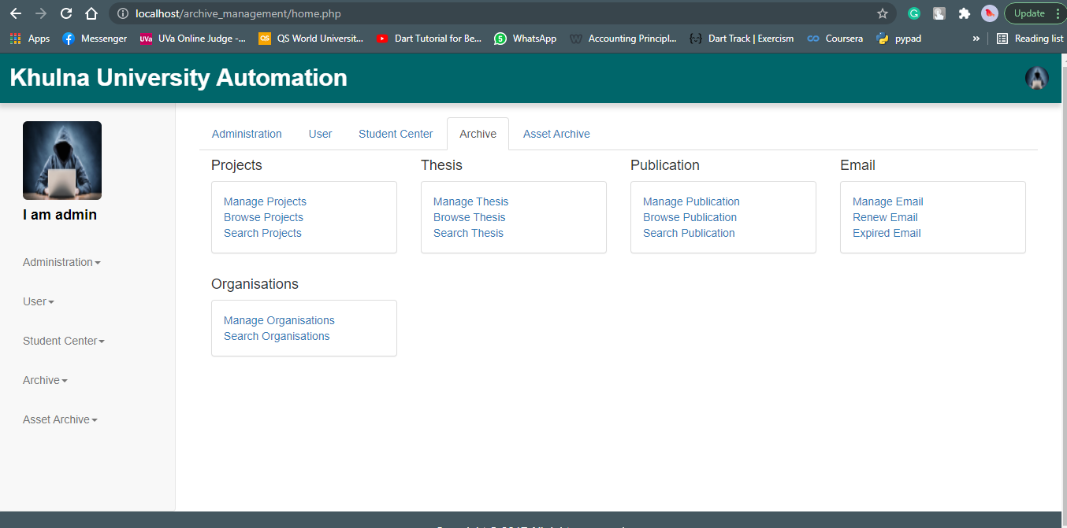

Fig 2: UI of Archive Section

The Project section consists of three sub-sections such as,

1. Manage Project
2. Browse Project
3. Search Project

**Project Archive:**

1. **Manage Projects:** In this sub-section admin can create, update and delete project. The route is **Home -> Archive -> Projects -> Manage Projects**.

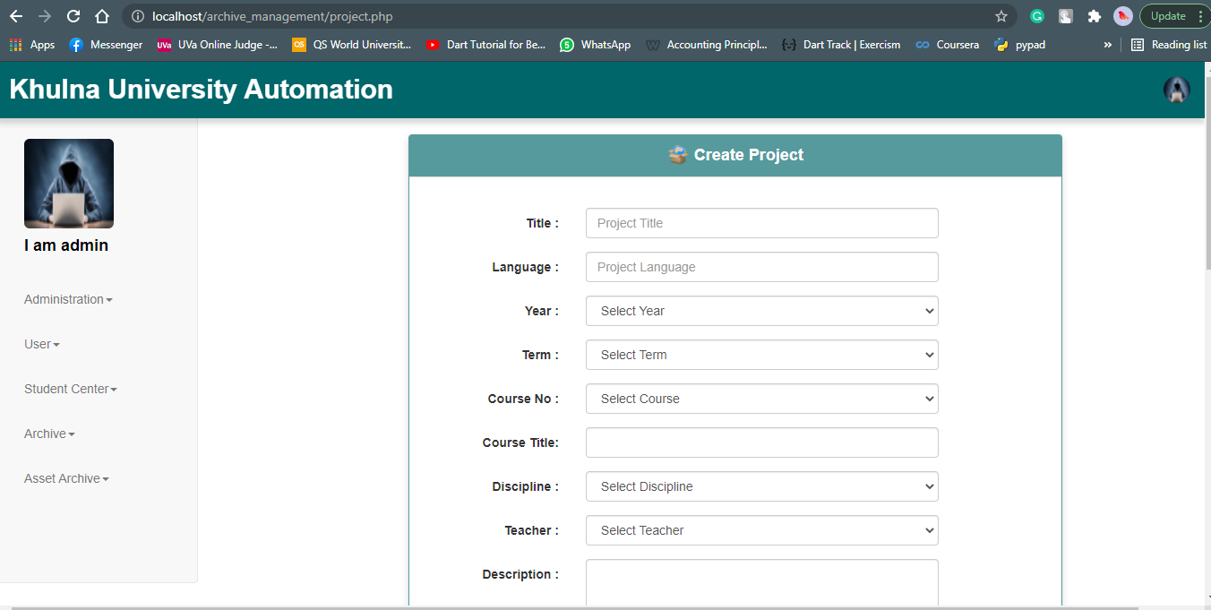

Fig 3: UI of Create Project.

1. **Browse Project:** In this sub-section admin can browse, update and delete specific project. The route is **Home -> Archive -> Projects -> Browse Projects**.

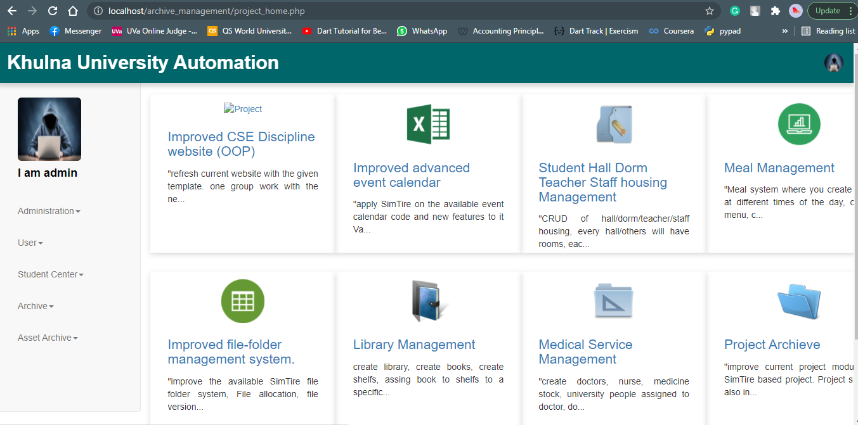

Fig 4: UI of Browse Project Section.

1. **Search Project:** In this sub-section user can search and browse specific project. The route is **Home -> Archive -> Projects -> Search Projects**.

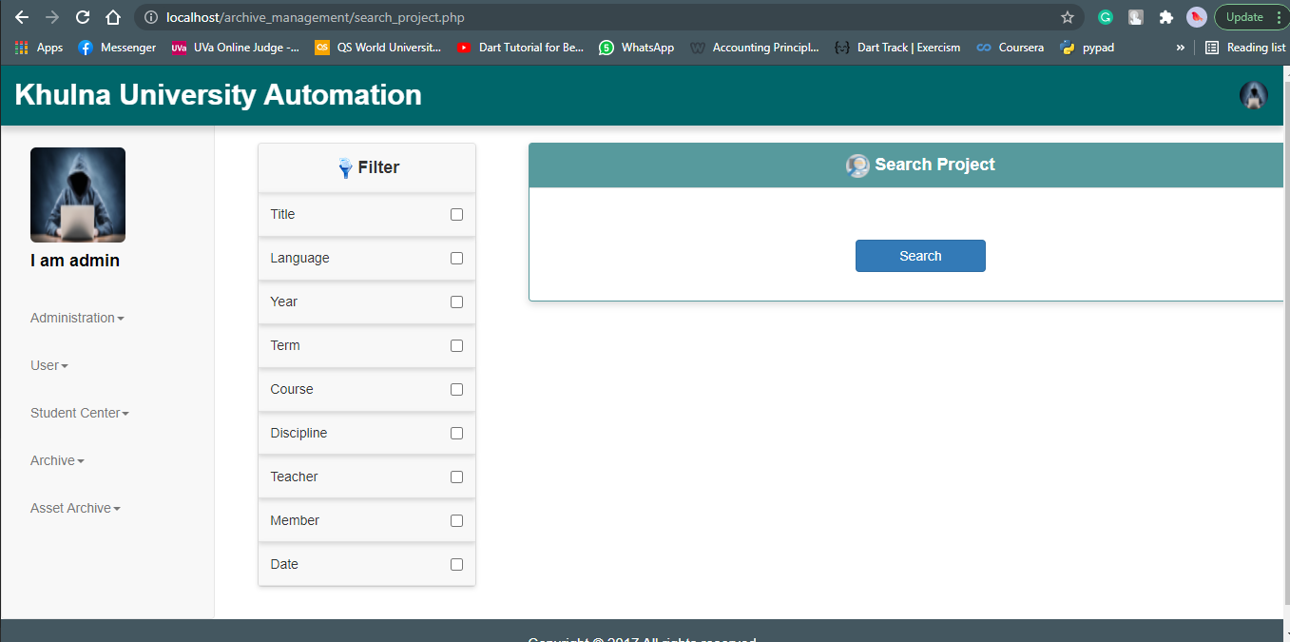

Fig 5: UI of Search Project Section.

The Thesis section consists of three sub-sections such as,

1. Manage Thesis
2. Browse Thesis
3. Search Thesis

**Thesis Archive:**

1. **Manage Thesis:** In this sub-section admin can create, update and delete Thesis records. The route is **Home -> Archive -> Thesis -> Manage Thesis.**

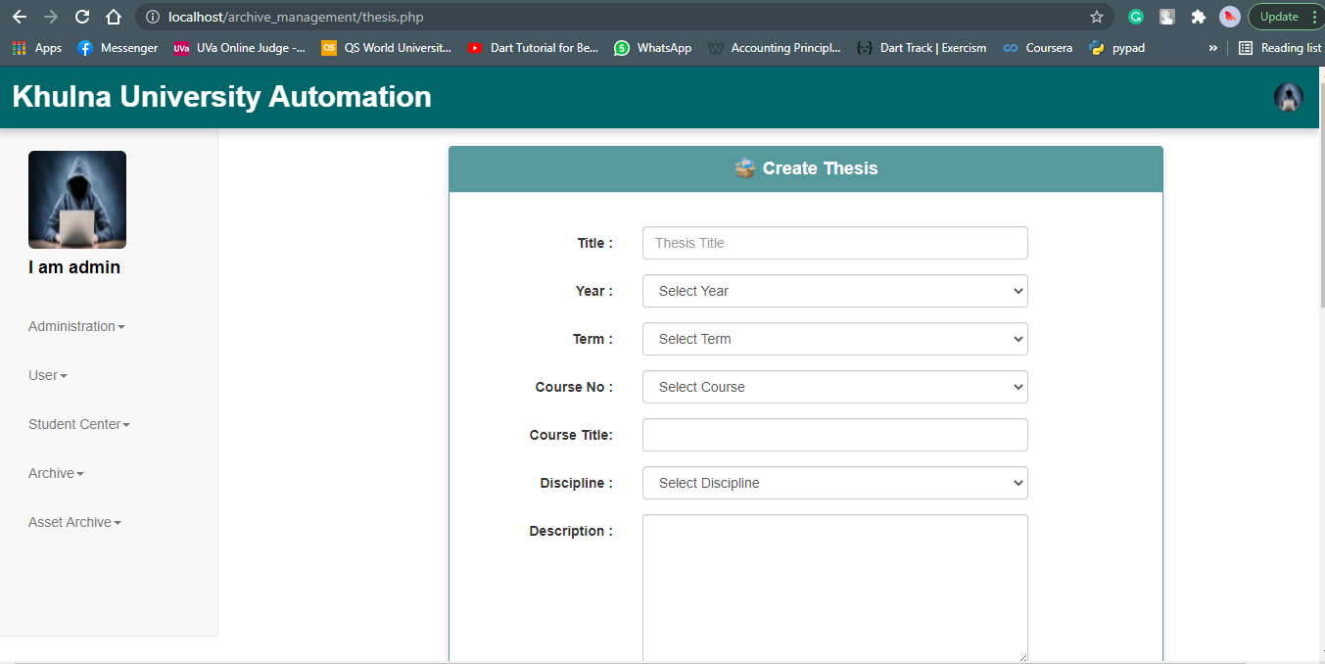

Fig 6: UI of Create Thesis Section.

1. **Browse Thesis:** In this sub-section admin can browse, update and delete specific Thesis. The route is **Home -> Archive -> Thesis -> Browse Thesis**.

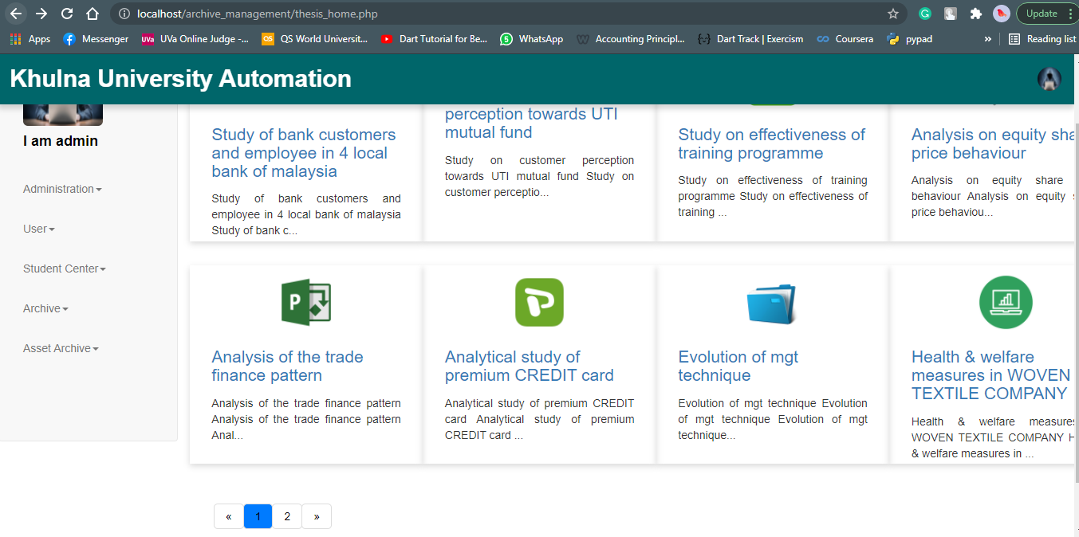

Fig 7: UI of Browse Thesis Archive Section.

User can click on specific record and will be able to see the details. The route is **Home -> Archive -> Thesis -> Browse Thesis -> (click on the desired topic).**

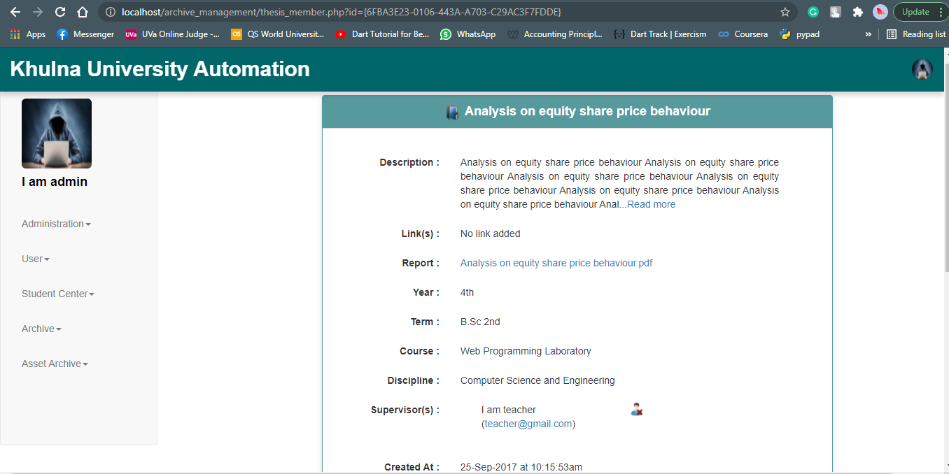

Fig 8: UI of Browse specific Thesis.

1. **Search Thesis:** In this sub-section user can search and browse specific Thesis. The route is **Home -> Archive -> Thesis -> Search Thesis**.

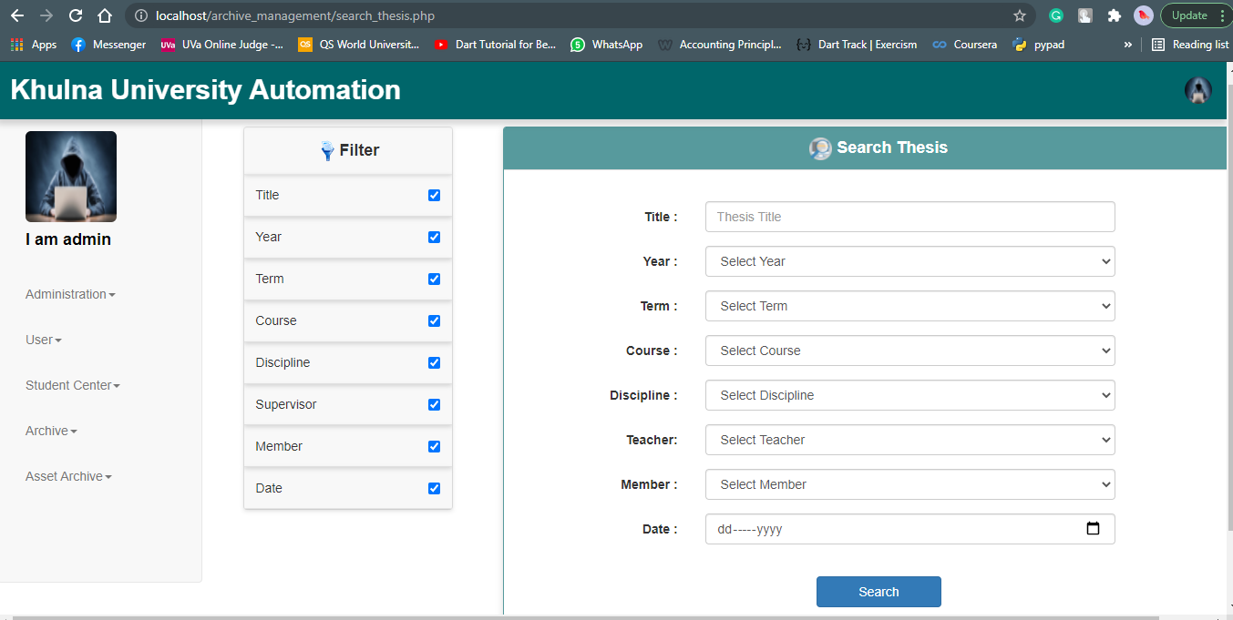

Fig 9: UI of Search Thesis Section.

The Publication section consists of three sub-sections such as,

1. Manage Publication
2. Browse Publication
3. Search Publication

**Publication Archive:**

1. **Manage Publication:** In this sub-section admin can create, update and delete Publication record. The route is **Home -> Archive -> Publication -> Manage Publication.**

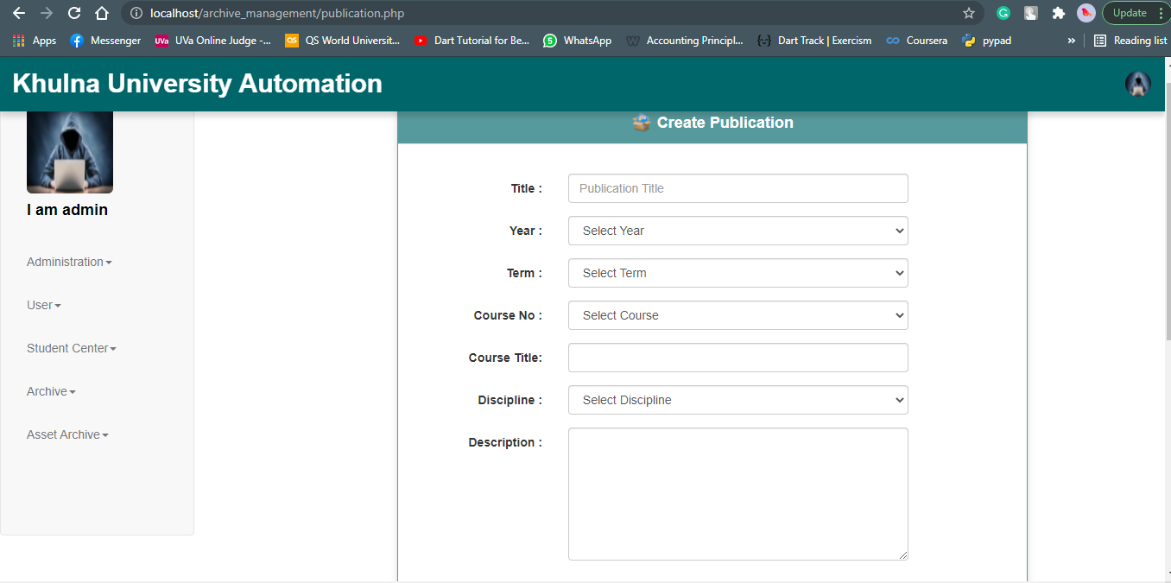

Fig 10: UI of Create Publication Section.

1. **Browse Publication:** In this sub-section admin can browse, update and delete specific Publication. The route is **Home -> Archive -> Publication -> Browse Publication.**

User can also add multiple links to that published article. The route is **Home -> Archive -> Publication -> Browse Publication ->Select Publication -> Add Link.**

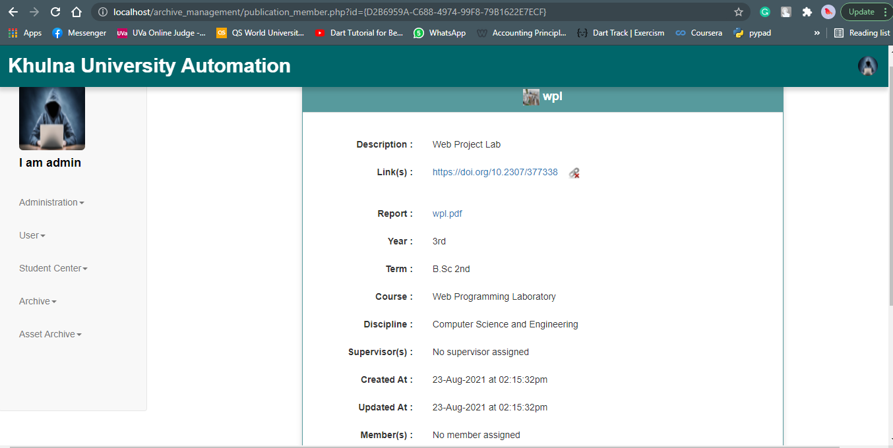

Fig 11: UI of Browse specific publication.

1. **Search Publication:** In this sub-section user can search and browse specific Publication. The route is **Home -> Archive -> Publication -> Search Publication.**

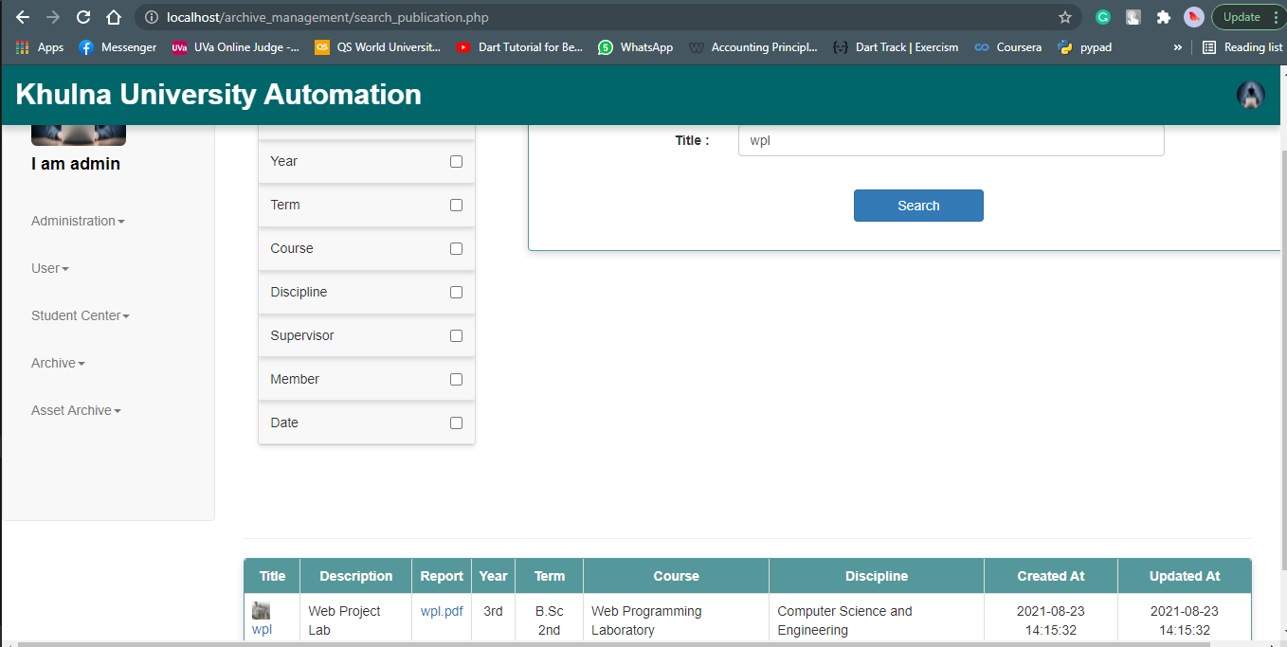

Fig 12: UI of Search Publication Section.

The Email section consists of three sub-sections such as,

1. Manage Email
2. Renew Email
3. Expired Email

**Email Archive:**

1. **Manage Email:** In this sub-section admin can create, update and delete Email record. The route is **Home -> Archive -> Email -> Manage Email**.

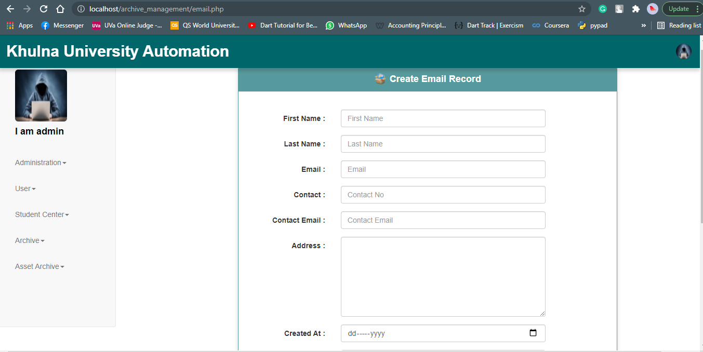

Fig 13: UI of Create Email Section

1. **Renew Email:** Renewed emails will be shown here. Admin can extend expire time here. The route is **Home -> Archive -> Email -> Renew Email**.

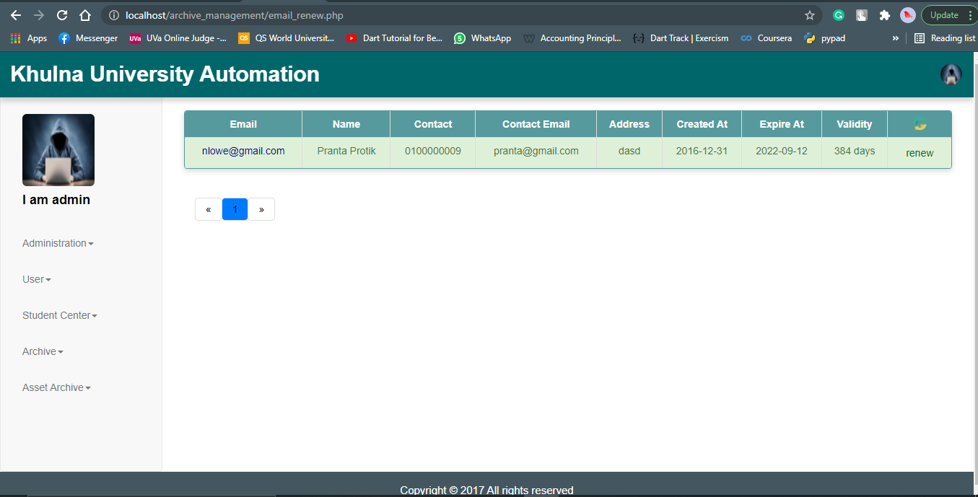

Fig 14: UI of Renew Email.

1. **Expired Email:** Expired emails will be shown here. Admin can extend expire time here. The route is **Home -> Archive -> Email -> Expired Email**.

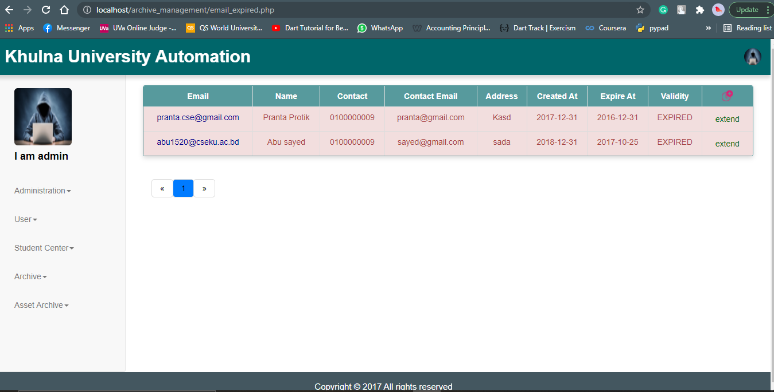

Fig 15: UI of Expired Email.

The Organisation section consists of three sub-sections such as,

1. Manage Thesis
2. Browse Thesis
3. Search Thesis

**Organisation Archive:**

1. **Manage Organisation:** In this sub-section admin can create, update and delete organisation. The route is **Home -> Archive -> Organisation -> Manage Organisation**.

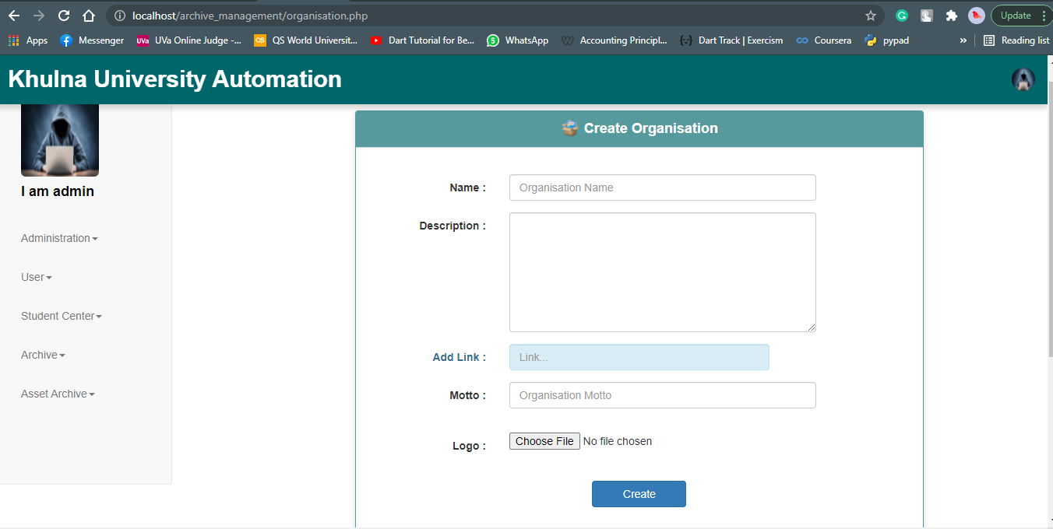

Fig 16: UI of Create Organisation Section.

1. **Browse Organisation:** In this sub-section admin can browse, update and delete specific organisation. The route is **Home -> Archive -> Organisation -> Manage Organisation -> (Click on any Organisation)**.

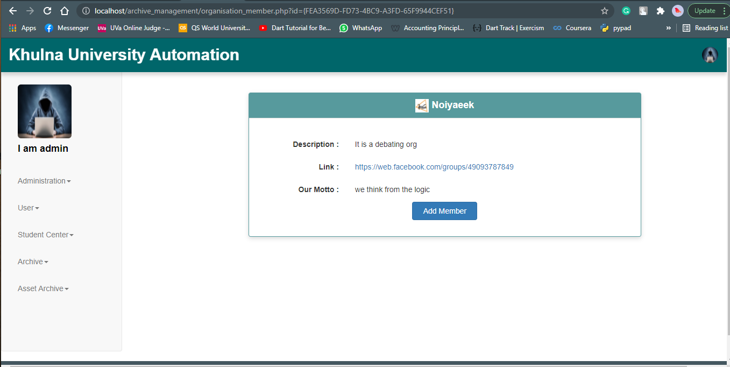

Fig 17: UI of Browsing specific Organisation.

There is another section for recording Organisation Members. Admin can manage these records. The rout is **Home -> Archive -> Organisation -> Manage Organisation -> (Click on any Organisation) -> Add Member.**

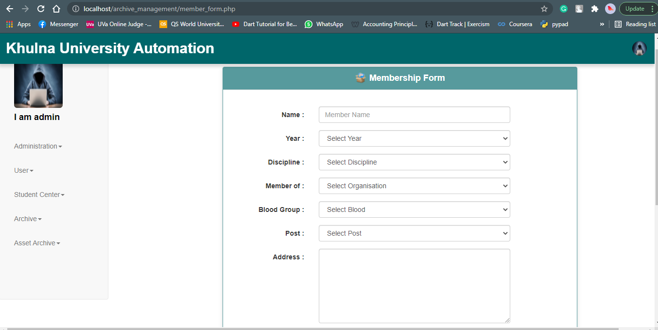

Fig 18: UI of Organisation Membership Form.

1. **Search Organisation:** In this sub-section user can search and find details of desired organisation.The route is **Home -> Archive -> Organisation -> Search Organisation**.

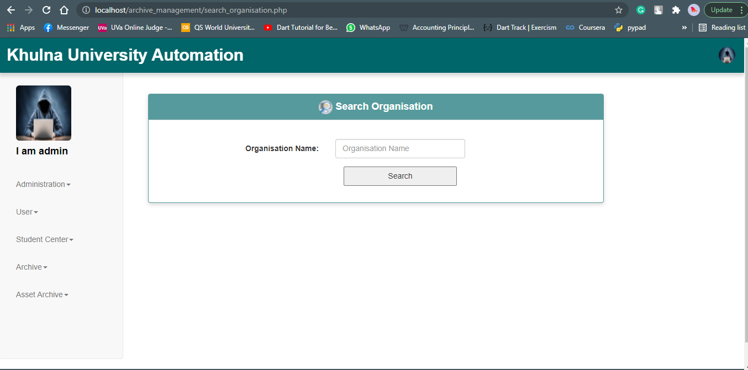

Fig 19: UI of Search Organisation Section.